aProject Design Phase-II
Data Flow Diagram & User Stories

Date | 31 January 2026
Team ID | LTVIP2026TMIDS71750
Project Name | OrderOnTheGo: Your On-Demand Food Ordering Solution
Maximum Mark | 4 Marks

Data Flow Diagrams:
OrderOnTheGo (SB Foods) connects customers, restaurants, and technology to deliver a fast, convenient, and reliable food ordering experience. The platform gathers data from users, restaurants, and third-party services—processes it—and provides real-time order management, secure payments, and delivery updates. Simple, efficient, and user-centric.
○ User interactions are handled through intuitive web and mobile interfaces for browsing menus, placing orders, and tracking deliveries.
○ Real-time data from restaurants, orders, and payment gateways is collected and processed securely.
○ Order status and delivery updates are monitored and notified instantly.
○ Payment transactions are processed securely with third-party integrations.
○ Insights and order history are generated for users, restaurants, and administrators to improve decision-making and service quality.
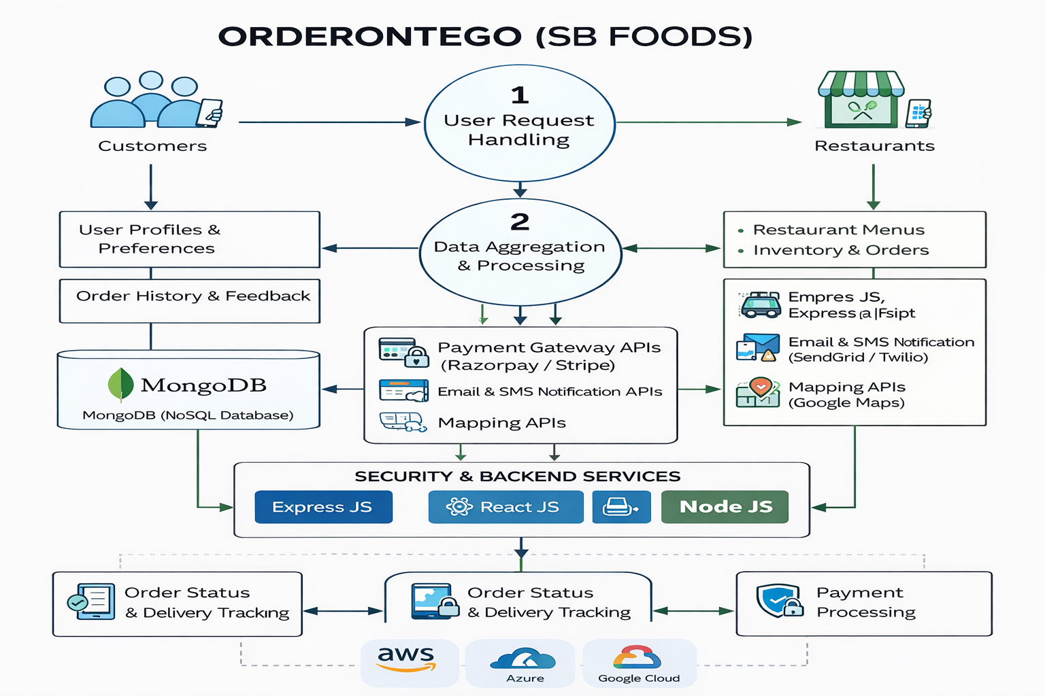

User Stories
User Stories – OrderOnTheGo (SB Foods)
● Customers want a fast and convenient way to browse nearby restaurants, view menus, place food orders, make secure payments, and track deliveries in real time, especially during late-night hours.
● Restaurant Owners need an easy-to-use dashboard to manage food listings, update availability, receive orders instantly, track order status, and analyze sales to improve customer satisfaction and business performance.
● Administrators focus on monitoring platform activity, managing users and restaurants, ensuring secure transactions, handling approvals, and maintaining overall system reliability and performance.

User Type | Functional Requirement (Epic) |  | User Story Number | User Story / Task | Acceptance Criteria | Priority | Release
Customer | Registration |  | USN-1 | As a customer, I want to register for the application so that I can place food orders easily. | User is able to successfully register using valid details and access the application. | High | Sprint-1
Customer | Login |  | USN-2 |  | User can log in with valid credentials and is redirected to the home page. | High | Sprint-1
  As a customer, I want to log in
  using email and password
  so that I can access my account.
Customer | Browse & Order |  | USN-3 | As a customer, I want to browse restaurants and menus so that I can choose my preferred food items. | Restaurants and menus load correctly with pricing and availability. | High | Sprint-1
Customer |  |  | USN-4 | As a customer, I want to add food items to my cart and place an order securely. | Items are added correctly, payment is successful, and order confirmation is shown. | High | Sprint-1
  Cart & Checkout
Customer |  |  | USN-5 | As a customer, I want to track my order status in real time. | Order status updates are displayed correctly until delivery. | Medium | Sprint-2
  Order Tracking
Restaurant Owner | Order Management |  | USN-6 |  | Orders appear instantly and status updates are reflected to customers. | High | Sprint-1
  As a restaurant owner, I want to receive and
  manage customer orders.
Restaurant Owner | Menu Management |  | USN-7 | As a restaurant owner, I want to add and update food items. | Menu changes are saved and visible to customers immediately. | Medium | Sprint-2
Administrator | Platform Management |  | USN-8 | As an admin, I want to manage users, restaurants, and orders. | Admin can view, approve, or block users and restaurants securely. | Medium | Sprint-2
Administrator | Monitoring & Security |  | USN-9 |  | System logs, user activity, and errors are tracked correctly. | Medium | Sprint-2
  As an admin, I want to monitor system activity
  to ensure smooth operation.

